The initial question :

We think that "Original size" mode brings a lot of problems:
For authors and viewers:
- If you create a slide with several objects that all have "Original size" mode, these objects won't be correctly placed at different screen resolutions.
- Impossible to correctly export slideshow for DVD, Youtube, iPhone, because of lower video file resolution (480 x 320) - all objects will be shown incorrectly.
For us as developers:
- The more and more difficult to support it with all new added features. It vastly complicates the code of PicturesToExe.

Benefits:
- Correct placement of objects at any screen resolution.
- Creating video for iPhone, Youtube without any problems.
- Exact mapping of image pixels to display pixels, sharp picture without resizing/re-sampling, as earlier.

The proposal :

This proposal is a synthesis of all the proposals made before to solve the problem about simplicity of algorithm of PTE without the lose of original mode and use a function to correct the problems we had when slideshow run on a screen definition which isn't the one chose by author and the problem about export slideshow on DVD or other.
It’s the complete answer to the question.
1- Structure
The idea is always to define a Nominal format (NF) when building the slideshow, for instance 1920 x 1280. This Nominal format become an object at level 0 we call Virtual Object Format (VOF).
This Virtual Object Format (VOF) with the size of Nominal format (NF) have Zoom’s values calculate by PTE. It is the parent of all level 1 objects.
PTE will calculate the size of the Format On Screen (FOS) depending of the values give by user for nominal format (NF), screen options (Fit to screen and so on), % Format size on screen and Window definition (Windowed mode) give by user or screen definition of the computer on which PTE run.
This value (FOS) is always an even value as today with a simplest formulas as today..
PTE calculate the 2 zoom values to put at the Virtual Object Format (VOF), an horizontal zoom and a vertical zoom in order it is exactly as the same size as Format on Screen (FOS)
So a picture having the size of Nominal Format (NF) at level 1 with Zoom 100% will be resized by PTE exactly at the size of Format on Screen (FOS), no matter the mode give at this picture (Fit to slide, Cover slide or Original mode).

FOS and VOF has always exactly the same size
The picture below show the structure and the relationship between all PTE elements :
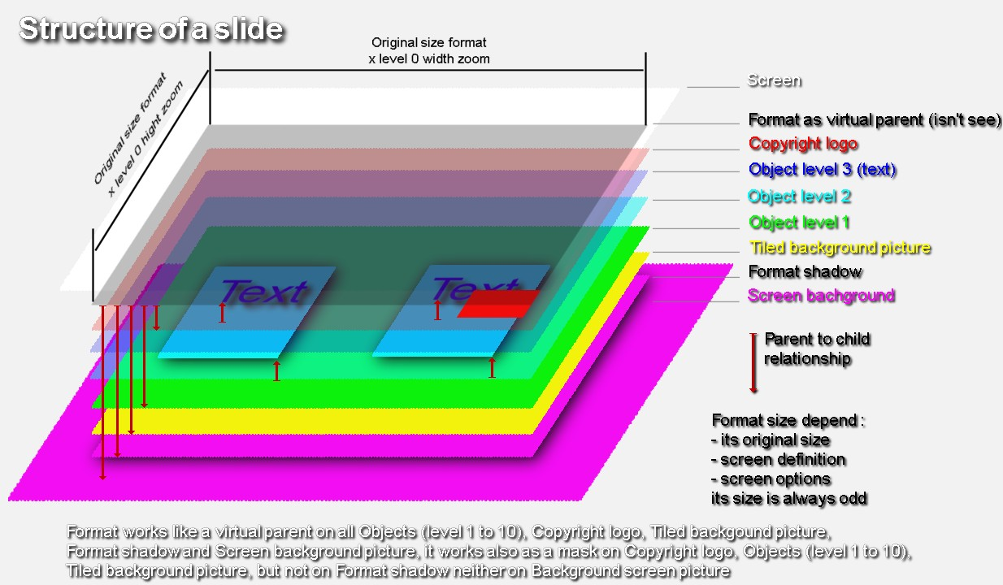
The relationship between the virtual object Format (VOF) and its children is exactly the same as this between object level 1 in Original, Fit to slide or Cover to Slide mode and object level 2 in Original, Fit to slide or Cover to Slide mode as we have in V5.5.

This virtual object Format (VOF) can have a real shadow.
All the objects in Object and animation Window have the same characteristics than actual objects in V5.5 for mode (3 options) and position in Pixels or Percents as we have today in V5.5.
2- Screen options
There are 5 options about adjust (or not) the Format on screen (FOS) to current screen or Window :
- The full format is Fit to screen
- The full format is in original mode if screen definition greater than format definition, and fit to screen if screen definition smaller as format definition (as it was in V4 for Main Image)
- The full format is Fit to height of screen
- The full format is Fit to Window, with 2 Options for Window :
..... - The window is always at the size which is define (as in V5.5)
..... - The window is at its size if the screen definition is greater, and is Fit to screen if the screen definition is smaller (as in V5.6)
An option permit to adjust format in % of its full size (today it's only on main images)
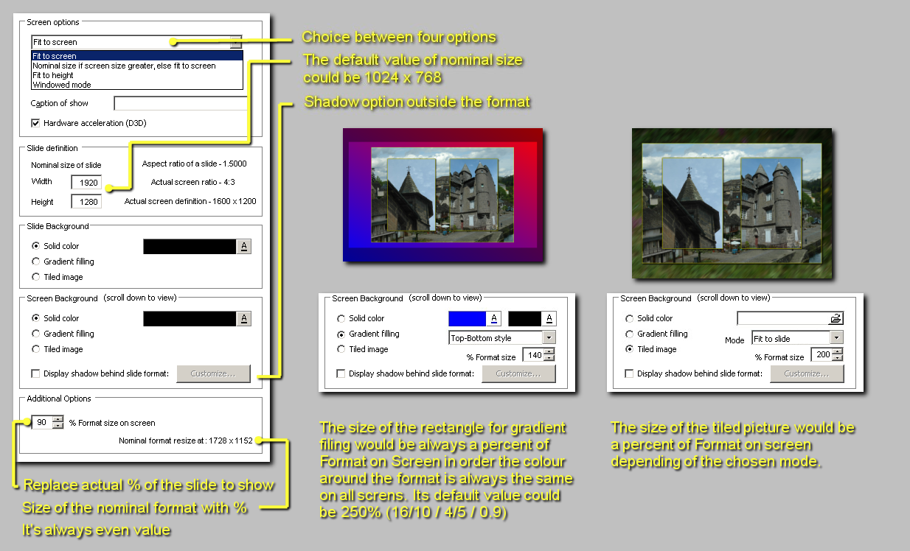
This option % Format size on screen could be use to make DVD but also by those which enough often want to use only 95% or 90% of the screen (often with a frame).
It’s for this reason we have Nominal resize at…. that PTE give, so that if people made a 1728 x 1152 picture for a slideshow with 1920 x 1280 Nominal Size of Format (NF), if they put this picture with Cover or Fit to slide, the picture will be at its original size when 90 % Format size on screen with a screen definition of 1920 x 1440.
User will define the rectangle for Gradient filing as a percent of the Format on screen (FOS), always equal at 100% or more in order that the colour around the Format on screen is always the same. The default value could be 250% ( about what is need for a 4:5 slideshow at 90% see on a 16:9 screen).
The tiled image could be in one of the 3 standards mode in percent of the Virtual Object Format - VOF (see definition at 2.1)
A shadow is possible around the Format On Screen (FOS) and is resize like the FOS
......2.1 Fit to screen option
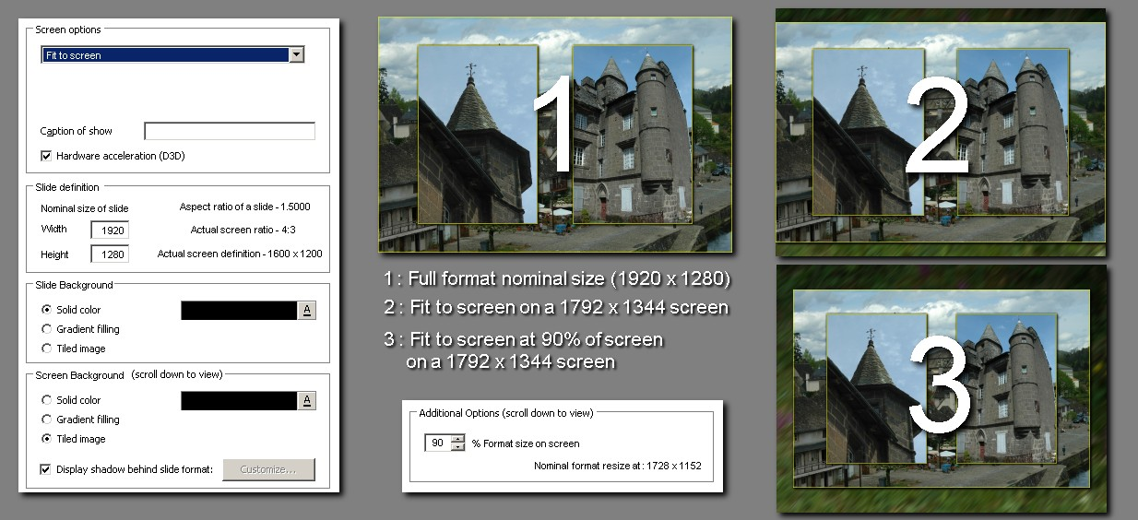
Calculation of the Format On Screen (FOS) :
1 - define the useful area :
......Screen_width x Percent_format_on_screen = Width_area
......Screen_height x Percent_format_on_screen = Height_area
2 - search the minimal ratio between Width of area/format and Height of area/format
......Width area / Width nominal format = Width ratio
......Height area / Height nominal format = Height ratio
......Ratio = min (Width ratio; Height ratio)
3 - Find the value of the Format on screen (FOS) which must be an even value :
......Width on screen = Nearest entire value (Width_nominal_format x Ratio / 2) x 2
......Height on screen = Nearest entire value (Height_nominal_format x Ratio / 2) x 2
4 - Calculate the values of zoom to put in the Virtual Object Format (VOF) in order it have the same size as format on screen (FOS)
......Width_zoom = Width_on_screen / Width_nominal_format
......Height_zoom = Height_on_screen / Height_nominal_format
The part of calculation in blue is the same for all screen options
Example #01 :

If we take the example above, the size of the nominal format (NF) is 1920 x 1280.
We use a screen definition 1792 x 1344 display (4:3)
We first choice 100% as format size on screen the values will be :
1 - define the useful area :
......1792 x 100% = 1792
......1344 x 100% = 1344
2 - search the minimal ratio between Width of area/format and Height of area/format
......1792 / 1920 = 93.333333%
......1344 / 1280 = 105.00000%
......Ratio = 93.333333%
3 - Find the value of the format on screen (FOS) which must be an even value :
......Width on screen = Nearest entire value (1920 x 93.333333% / 2) x 2
......Height on screen = Nearest entire value (1280 x 93.333333% / 2) x 2
......Width on screen = Nearest entire value (1792 / 2) x 2
......Height on screen = Nearest entire value (1194.666667 / 2) x 2
......Width on screen = Nearest entire value (896) x 2
......Height on screen = Nearest entire value (597.333333) x 2
......Width on screen = 896 x 2 = 1792
......Height on screen = 597 x 2 = 1194
4 - Calculate the values of zoom to put in the virtual object Format (VOF)
......Width zoom = 1792 / 1920 = 93.333333%
......Height zoom = 1194 / 1280 = 93.281250%
Example #02 :

Now we choice 90% as format size on screen the values will be :
1 - define the useful area :
......1792 x 90% = 1612.8
......1344 x 90% = 1209.6
2 - search the minimal ratio between Width of area/format and Height of area/format
......1612.8 / 1920 = 84.000000%
......1209.6 / 1280 = 94.500000%
......Ratio = 84.0000000%
3 - Find the value of the format on screen which must be an even value :
......Width on screen = Nearest entire value (1920 x 84.000000% / 2) x 2
......Height on screen = Nearest entire value (1280 x 84.000000% / 2) x 2
......Width on screen = Nearest entire value (1612.8 / 2) x 2
......Height on screen = Nearest entire value (1075.2 / 2) x 2
......Width on screen = Nearest entire value (806.4) x 2
......Height on screen = Nearest entire value (537.6) x 2
......Width on screen = 806 x 2 = 1612
......Height on screen = 538 x 2 = 1076
4 - Calculate the values of zoom to put in the virtual object Format (VOF)
......Width zoom = 1612 / 1920 = 83.958333%
......Height zoom = 1076 / 1280 = 84.062500%
On a 1920 x 1440 screen definition display, with 100% as format size on screen, the 2 zooms of format would be at 100% and objects under the Virtual object format (VOF) wouldn't be resized by it.
......2.2 Nominal size if screen greater, else Fit to screen
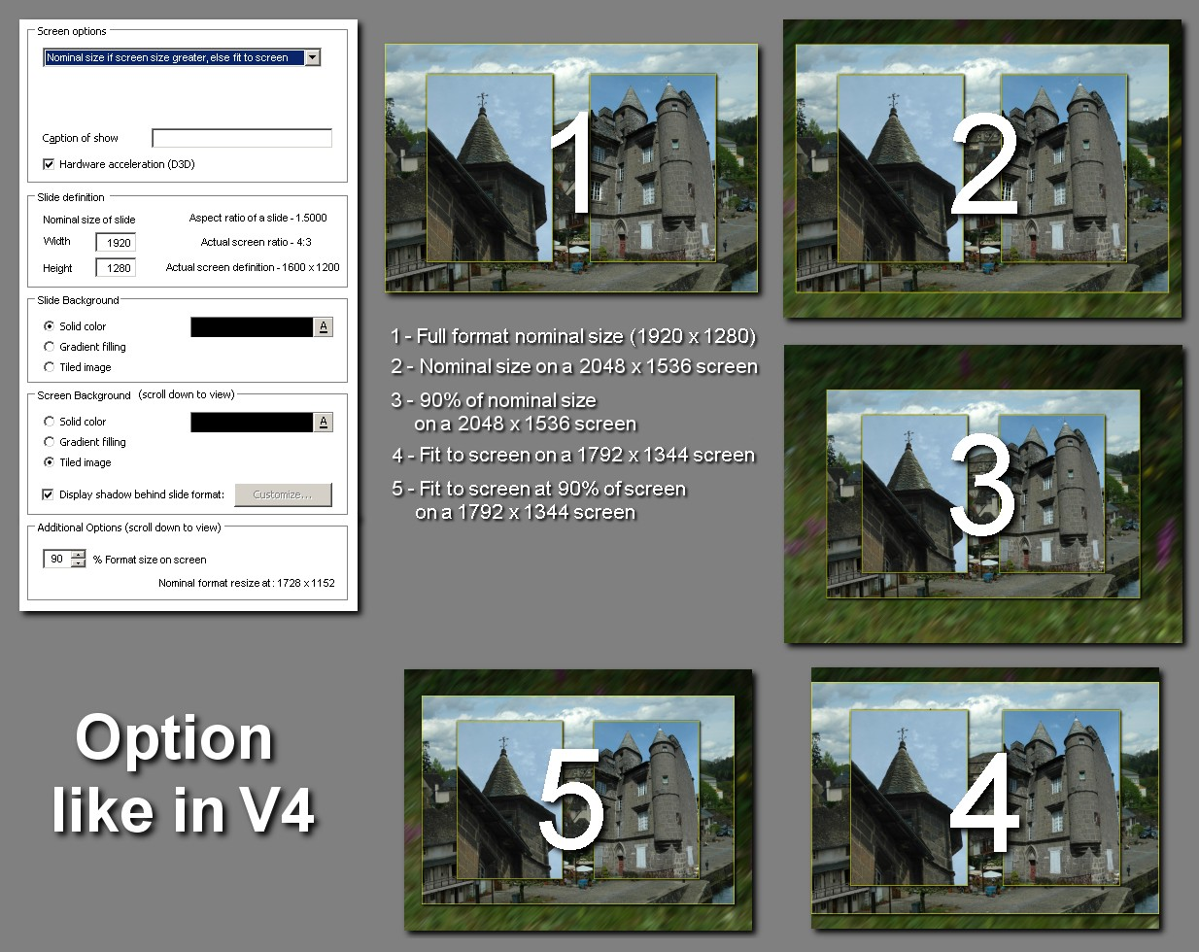
Calculation of the Format On Screen (FOS) :
1 - define the useful area :
......Smallest value between (Width_nominal_format;Screen_width) x Percent_format_on_screen = Width_area
......Smallest value between (Height_nominal_format ;Screen_height) x Percent_format_on_screen = Height_area
Others calculations like for Fit to screen option (point 2 - 4)
Example #03 :

If we take the example above, the size of the nominal format is 1920 x 1280.
We use a screen definition 2048 x 1536 display (4:3)
We first choice 100% as format size on screen the values will be :
1 - define the useful area :
......Smallest value between (1920; 2048) * 100% = 1920 (Width)
......Smallest value between (1280; 1536) * 100% = 1280 (Height)
2 - search the minimal ratio between Width of area/format and Height of area/format
......1920 / 1920 = 100%
......1280 / 1280 = 100%
......Ratio = 100%
3 - Find the value of the format on screen (FOS) which must be an even value :
......Width on screen = Nearest entire value (1920 x 100% / 2) x 2
......Height on screen = Nearest entire value (1280 x 100% / 2) x 2
......Width on screen = Nearest entire value (1920 / 2) x 2
......Height on screen = Nearest entire value (1280 / 2) x 2
......Width on screen = Nearest entire value (960) x 2
......Height on screen = Nearest entire value (640) x 2
......Width on screen = 960 x 2 = 1920
......Height on screen = 640 x 2 = 1280
4 - Calculate the values of zoom to put in the virtual object Format (VOF)
......Width zoom = 1920 / 1920 = 100%
......Height zoom = 1280 / 1280 = 100%
Example #04 :

Now we choice 90% as format size on screen the values will be :
1 - define the useful area :
......Smallest value between (1920; 2048) * 90% = 1728 (Width)
......Smallest value between (1280; 1536) * 90% = 1152 (Height)
2 - search the minimal ratio between Width of area/format and Height of area/format
......1728 / 1920 = 90.000000%
......1152 / 1280 = 90.000000%
......Ratio = 90.000000%
3 - Find the value of the format on screen (FOS) which must be an even value :
......Width on screen = Nearest entire value (1920 x 90.000000% / 2) x 2
......Height on screen = Nearest entire value (1280 x 90.000000% / 2) x 2
......Width on screen = Nearest entire value (1728 / 2) x 2
......Height on screen = Nearest entire value (1152 / 2) x 2
......Width on screen = Nearest entire value (864) x 2
......Height on screen = Nearest entire value (576) x 2
......Width on screen = 864 x 2 = 1728
......Height on screen = 576 x 2 = 1152
4 - Calculate the values of zoom to put in the virtual object Format (VOF)
......Width zoom = 1728 / 1920 = 90%
......Height zoom = 1076 / 1280 = 90%
The others examples are as Fit to screen (see 2.1)
......2.3 Fit to height
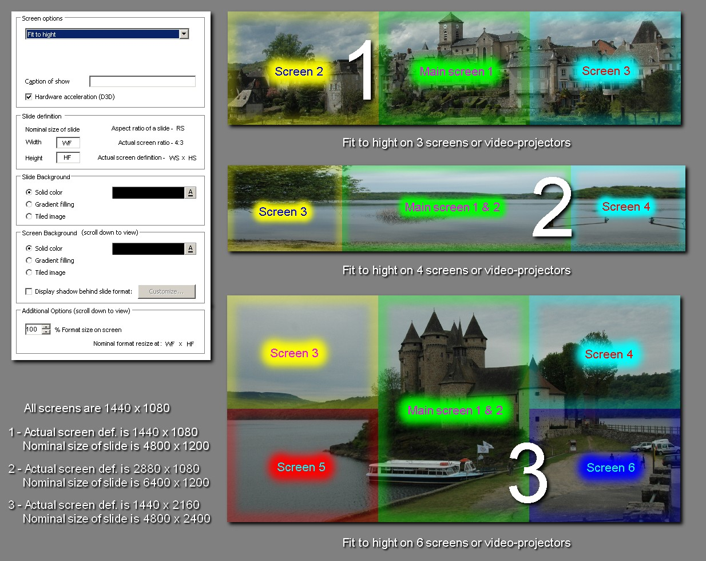
Calculation of the format :
1 - define the useful area :
......Width_nominal_format / Height_nominal_format x Screen_height x Percent_format_on_screen = Width area
......Screen_height x Percent_format_on_screen = Height area
Others calculations like for Fit to screen option (point 2 - 4)
Example #05 :

If we take the examples above, we'll see that we can adjust a slideshow on several screens at the same time. Today we only do that in V5.5 in Windowed mode, without possibilities to fit to height.
For the first example we have a slideshow with a format definition of 4800 x 1200 for 3 screens or video projectors having a format 4:3 with a definition of 1440 x 1080. The % format on screen is 100%.
1 - define the useful area :
......4800 / 1200 x 1080 x 100% = 4320
......1080 x 100% = 1080
2 - search the minimal ratio between Width of area/format and Height of area/format
......4800 / 4320 = 90%
......1200 / 1080 = 90%
......Ratio = 90%
3 - Find the value of the format on screen (FOS) which must be an even value :
......Width on screen = Nearest entire value (4800 x 90% / 2) x 2
......Height on screen = Nearest entire value (1200 x 90% / 2) x 2
......Width on screen = Nearest entire value (4320 / 2) x 2
......Height on screen = Nearest entire value (1080 / 2) x 2
......Width on screen = Nearest entire value (2160) x 2
......Height on screen = Nearest entire value (540) x 2
......Width on screen = 2160 x 2 = 4320
......Height on screen = 540 x 2 = 1080
4 - Calculate the values of zoom to put in the virtual object Format (VOF)
......Width zoom = 4320 / 4800 = 90%
......Height zoom = 1080 / 1200 = 90%
Example #06 :

For the second example we have a slideshow with a format definition of 4096 x 768 for 4 screens or video projectors having a format 4:3 with a definition of 1280 x 960. The % format on screen is 100%.
Note : the 2 screens in the middle are see as only one screen in horizontal and are see as a 2560 x 960 screen definition (see graphic card parameters)
1 - define the useful area :
......4096 / 768 x 960 x 100% = 5120
......960 x 100% = 960
2 - search the minimal ratio between Width of area/format and Height of area/format
......5120 / 4096 = 125%
......960 / 768 = 125%
......Ratio = 125%
3 - Find the value of the format on screen (FOS) which must be an even value :
......Width on screen = Nearest entire value (4096 x 125% / 2) x 2
......Height on screen = Nearest entire value (768 x 125% / 2) x 2
......Width on screen = Nearest entire value (5120 / 2) x 2
......Height on screen = Nearest entire value (960 / 2) x 2
......Width on screen = Nearest entire value (2560) x 2
......Height on screen = Nearest entire value (480) x 2
......Width on screen = 2560 x 2 = 5120
......Height on screen = 480 x 2 = 960
4 - Calculate the values of zoom to put in the virtual object Format (VOF)
......Width zoom = 5120 / 4096 = 125%
......Height zoom = 960 / 768 = 125%
Example #07 :

For the third example we have a slideshow with a format definition of 4800 x 2400 for 6 screens or video projectors having a format 4:3 with a definition of 1440 x 1080. The % format on screen is always at100%.
Note : the 2 screens in the middle are see as only one screen in vertical and are see as a 1440 x 2160 screen definition (see graphic card parameters)
1 - define the useful area :
......4800 / 2400 x 2160 x 100% = 4320
......2160 x 100% = 2160
2 - search the minimal ratio between Width of area/format and Height of area/format
......4320 / 4800 = 90%
......2160 / 2400 = 90%
......Ratio = 90%
3 - Find the value of the format on screen (FOS) which must be an even value :
......Width on screen = Nearest entire value (4800 x 90% / 2) x 2
......Height on screen = Nearest entire value (2400 x 90% / 2) x 2
......Width on screen = Nearest entire value (4320 / 2) x 2
......Height on screen = Nearest entire value (2160 / 2) x 2
......Width on screen = Nearest entire value (2160) x 2
......Height on screen = Nearest entire value (1080 x 2
......Width on screen = 2160 x 2 = 4320
......Height on screen = 1080 x 2 = 2160
4 - Calculate the values of zoom to put in the virtual object Format (VOF)
......Width zoom = 4800 / 4320 = 90%
......Height zoom = 2400 / 2160 = 90%
For these 3 examples, the calculations could be simplest but here, it use the same way of calculation as the others options ( blue lines) in order to use always the same process.
This option is useful for those who make stereo slideshows, cinemascope slideshow and wall of images. There are today, since several years V4 and V5 slideshows like that, now with mask it's more possible because we can easily make Pan, Zoom and Rotation on such slideshow, before it was impossible or very difficult.
......2.4 Windowed mode (2 options)
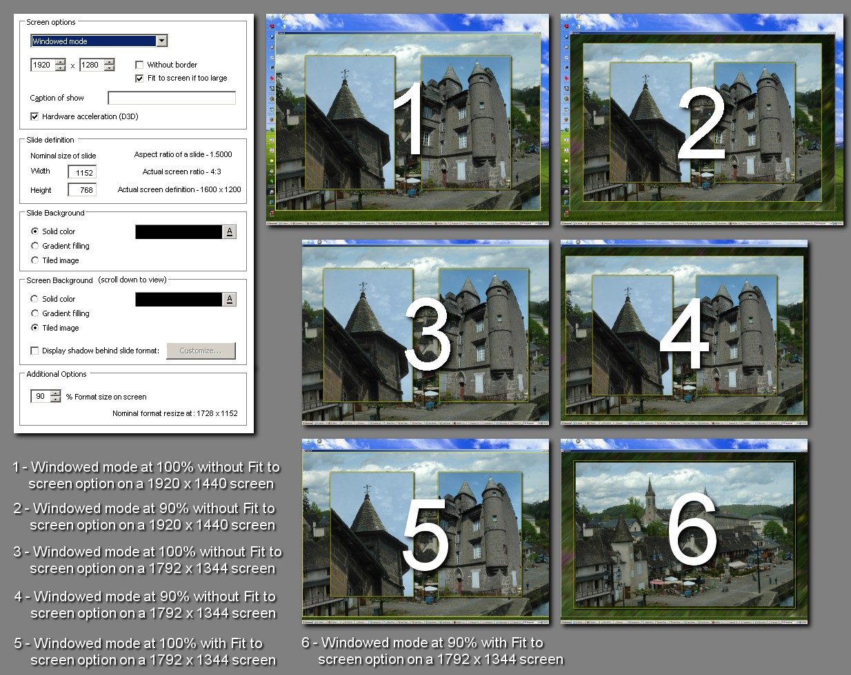
For these modes, the format is always "Fit to Window" but with % format on screen
Calculation of the format :
1 - define the useful area :
....1.1 Without Option "Fit to screen if too large" (as in V5.52) :
......Window_width x Percent_format_on_screen = Width area
......Window_height x Percent_format_on_screen = Height area
....1.2 With Option "Fit to screen if too large" (as in 5.6 beta #1) :
......Smallest value between (Screen_width;Window_width) x Percent_format_on_screen = Width area
......Smallest value between (Screen_height;Window_height) x Percent_format_on_screen = Height area
Others calculations like for Fit to screen option (point 2 - 4)
Example #08 :

For the first example we have a slideshow with a format definition of 1152 x 768 and a 1920 x 1280 window on a 2048 x 1536 screen definition with 100% for "Format size on screen" with or without the option "Fit to screen if too large", the result will be the same:
1 - define the useful area :
...1.1 - Without option "Fit..."
......1920 x 100% = 1920
......1280 x 100% = 1280
..1.2 - With option "Fit..."
......Smallest value between (2048;1920) x 100% = 1920
......Smallest value between (1536;1280) x 100% = 1280
2 - search the minimal ratio between Width of area/format and Height of area/format
......1920 / 1152 = 166.666667%
......1280 / 768 = 166.666667%
......Ratio = 166.666667%
3 - Find the value of the format on screen (FOS) which must be an even value :
......Width on screen = Nearest entire value (1152 x 166.666667% / 2) x 2
......Height on screen = Nearest entire value (768 x 166.666667% / 2) x 2
......Width on screen = Nearest entire value (1920 / 2) x 2
......Height on screen = Nearest entire value (1280 / 2) x 2
......Width on screen = Nearest entire value (960) x 2
......Height on screen = Nearest entire value (640) x 2
......Width on screen = 960 x 2 = 1920
......Height on screen = 640 x 2 = 1280
4 - Calculate the values of zoom to put in the virtual object Format (VOF)
......Width zoom = 1920 / 1152 = 166.666667%
......Height zoom = 1280 / 768 = 166.666667%
Example #09 :

For the second example we have a slideshow with a format definition of 1152 x 768 and a 1920 x 1280 window on a 2048 x 1536 screen definition with 90% for "Format size on screen" with or without the option "Fit to screen if too large", the result will be the same :
1 - define the useful area :
...1.1 - Without option "Fit..."
......1920 x 90% = 1728
......1280 x 90% = 1152
..1.2 - With option "Fit..."
......Smallest value between (2048;1920) x 90% = 1728
......Smallest value between (1536;1280) x 90% = 1152
2 - search the minimal ratio between Width of area/format and Height of area/format
......1728 / 1152 = 150.000000%
......1152 / 768 = 150.000000%
......Ratio = 150.000000%
3 - Find the value of the format on screen (FOS) which must be an even value :
......Width on screen = Nearest entire value (1152 x 150% / 2) x 2
......Height on screen = Nearest entire value (768 x 1150% / 2) x 2
......Width on screen = Nearest entire value (1728 / 2) x 2
......Height on screen = Nearest entire value (1152 / 2) x 2
......Width on screen = Nearest entire value (864) x 2
......Height on screen = Nearest entire value (576) x 2
......Width on screen = 864 x 2 = 1728
......Height on screen = 576 x 2 = 1152
4 - Calculate the values of zoom to put in the virtual object Format (VOF)
......Width zoom = 1728 / 1152 = 150.000000%
......Height zoom = 1152 / 768 = 150.000000%
Example #10 :

For the third example we have a slideshow with a format definition of 1152 x 768 and a 1920 x 1280 window on a 1792 x 1344 screen definition with 100% for "Format size on screen" without the option "Fit to screen if too large", the useful area is the same as in example #8 :
1 - define the useful area :
...1.1 - Without option "Fit..."
......1920 x 100% = 1920
......1280 x 100% = 1280
The result for format on screen is the same as for example #8 : 1920 x 1280, the window (1920 x 1280) will be cut on screen (as in V5.5 today, very useful for Slideshows which needs several screens or video-projectors)
Example #11 :

For the fourth example we have a slideshow with a format definition of 1152 x 768 and a 1920 x 1280 window on a 1792 x 1344 screen definition with 90% for "Format size on screen" without the option "Fit to screen if too large", the useful area is the same as in example #9 :
1 - define the useful area :
...1.1 - Without option "Fit..."
......1920 x 90% = 1728
......1280 x 90% = 1152
The result for format on screen is the same as for example #9 : 1728 x 1152, the window 1920 x 1280) will be cut on screen (as in V5.5 today, very useful for Slideshows which needs several screens or video-projectors)
Example #12 :

For the fifth example we have a slideshow with a format definition of 1152 x 768 and a 1920 x 1280 window on a 1792 x 1344 screen definition with 100% for "Format size on screen" with the option "Fit to screen if too large".
1 - define the useful area :
......Smallest value between (1792;1920) x 100% = 1792
......Smallest value between (1344;1280) x 100% = 1280
2 - search the minimal ratio between Width of area/format and Height of area/format
......1792 / 1152 = 155.555556%
......1280 / 768 = 166.666667%
......Ratio = 155.555557%
3 - Find the value of the format on screen (FOS) which must be an even value :
......Width on screen = Nearest entire value (1152 x 155.555556% / 2) x 2
......Height on screen = Nearest entire value (768 x 155.555556% / 2) x 2
......Width on screen = Nearest entire value (1792 / 2) x 2
......Height on screen = Nearest entire value (1194.666667 / 2) x 2
......Width on screen = Nearest entire value (896) x 2
......Height on screen = Nearest entire value (597.333333) x 2
......Width on screen = 896 x 2 = 1792
......Height on screen = 597 x 2 = 1194
4 - Calculate the values of zoom to put in the virtual object Format (VOF)
......Width zoom = 1920 / 1152 = 155.555556%
......Height zoom = 1280 / 768 = 155.468750%
Example #13 :

For the sixth example we have a slideshow with a format definition of 1152 x 768 and a 1920 x 1280 window on a 1792 x 1344 screen definition with 90% for "Format size on screen" with the option "Fit to screen if too large".
1 - define the useful area :
......Smallest value between (1792;1920) x 90% = 1612.8
......Smallest value between (1344;1280) x 90% = 1152
2 - search the minimal ratio between Width of area/format and Height of area/format
......1612.8 / 1152 = 140.000000%
......1152 / 768 = 150.00000%
......Ratio = 140.00000%
3 - Find the value of the format on screen (FOS) which must be an even value :
......Width on screen = Nearest entire value (1152 x 140% / 2) x 2
......Height on screen = Nearest entire value (768 x 140% / 2) x 2
......Width on screen = Nearest entire value (1612.8 / 2) x 2
......Height on screen = Nearest entire value (1075.2 / 2) x 2
......Width on screen = Nearest entire value (806.4) x 2
......Height on screen = Nearest entire value (537.6) x 2
......Width on screen = 806 x 2 = 1612
......Height on screen = 538 x 2 = 1076
4 - Calculate the values of zoom to put in the virtual object Format (VOF)
......Width zoom = 1612 / 1152 = 139.930556%
......Height zoom = 1076 / 768 = 140.104167%
3 - Tiled background picture
3.1 Tiled background picture works as to day :

In order it's the same options as today for users and works with this proposal, there are some calculations to do :
1 - Resize the picture to fit the height of it to the height of the nominal format (NF) :
......Nominal format height / Picture height = Full height tiled picture ratio
2 - Resize the result with the percent we put in Customize slide window
......Full height tiled picture ratio x Customize percent for tiled picture = Customize nominal ratio for tiled picture
3 - Resize the new result with the same 2 values use for "Virtual object Format" (VOF)
......Width zoom tiled picture = Customize nominal ratio for tiled picture x Width zoom
......Height zoom tiled picture = Customize nominal ratio for tiled picture x Height zoom
An example of calculation :
Real size of Tiled picture 500 x 500
Size of image (in Customize slide window) : 50%
Others parameters are the same than sixth example of 2.4 Windowed mode above
Nominal size of format : 1152 x 768
% Format size on screen : 90
Windowed mode at 1920 x 1280 with "Fit to screen if too large option"
Screen definition : 1792 x 1344
With :
......Width zoom = 139.930556%
......Height zoom = 140.104167%
1 - Resize the picture to fit the height to the height of the nominal format :
......768 / 500 = 153.600%
2 - Resize the result with the percent we put in Customize slide window
......153.600% x 50% = 76.800%
3 - Resize the new result with the same 2 values use for "Virtual parent Format"
......107.466667% = 76.800% x 139.930556%
......107.466667% = 76.800% x 140.104167%
The size of the tiled picture on this screen will be :
width = 537.332 pixels (1), height = 538 pixels
(1) the value would really be 537.33334; but the least step for pixel is 1/256, so the nearest value is 537.332

3.2 Tiled background picture works as others objects :

The most important difference with others objects is tiled function more :

Others difference : No center function, Pan is always in percent and mode is always in Fit to slide mode and no rotation in order to haven’t too much options in the window.
In order it’s easiest for beginners, there would be the same others parameters to put :
Horizontal and vertical pan (always in percent)
Horizontal and vertical zoom
It would be in Fit to slide mode with Virtual object Format (VOF) as “parent”.

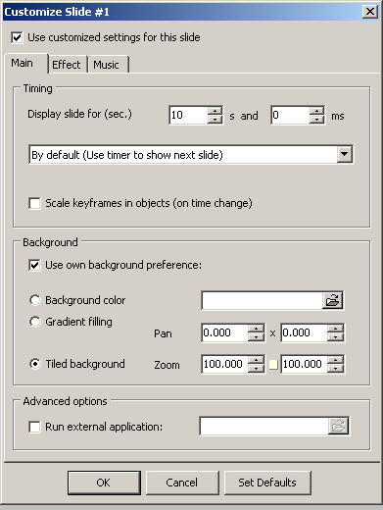

4 - Copyright logo

4.1 Copyright logo works as to day :
It could be possible to have only Pan and zoom as information to put the Copyright logo but in order it's the same options as today for users and works with this proposal, there are some calculations to do :
1 - Resize the logo to fit the height of it to the height of the nominal format :
......Nominal format height / Logo height = Full height logo ratio
2 - Resize the result with the percent we put in Customize Copyright logo window
......Full height logo ratio x Customize percent for logo = Customize nominal ratio for logo
3 - Resize the new result with the same 2 values use for "Virtual parent Format"
......Width zoom logo = Customize nominal ratio for logo x Width zoom
......Height zoom logo = Customize nominal ratio for logo x Height zoom
4 - We also have to calculate the horizontal and vertical pan for the different actual options and the value of the offset for the nominal format :
.....There are 2 parameters for this position :
........1 - a position
........2 - an offset value
The final position of the center of the logo for nominal format depend of the reference position (0% or 100%) + or - the offset which is a percent of half format + or - half of picture for nominal format (width or height).
4.1.1 - Horizontal Pan for nominal format :
Left................................(Width_nominal_format x (Offset_percent - 100%) + Customize_nominal_ratio_for_logo x Logo_width) / 2
Right..............................(Width_nominal_format x (Offset_percent - 100%) + Customize_nominal_ratio_for_logo x Logo_width) / 2
Center............................Always 0
Left-Top.........................(Width_nominal_format x (Offset_percent - 100%) + Customize_nominal_ratio_for_logo x Logo_width) / 2
Right-Top........................(Width_nominal_format x (Offset_percent - 100%) + Customize_nominal_ratio_for_logo x Logo_width) / 2
Right-Bottom...................(Width_nominal_format x (Offset_percent - 100%) + Customize_nominal_ratio_for_logo x Logo_width) / 2
Left-Bottom.....................(Width_nominal_format x (Offset_percent - 100%) + Customize_nominal_ratio_for_logo x Logo_width) / 2
4.1.2 - Vertical pan for nominal format :
Top................................(Height_nominal_format x (Offset_percent - 100%) + Customize_nominal_ratio_for_logo x Logo_height) / 2
Bottom...........................(Height_nominal_format x (100% - Offset_percent) - Customize_nominal_ratio_for_logo x Logo_height) / 2
Center............................Always 0
Left-Top..........................(Height_nominal_format x (Offset_percent - 100%) + Customize_nominal_ratio_for_logo x Logo_height) / 2
Right-Top........................((Height_nominal_format x (Offset_percent - 100%) + Customize_nominal_ratio_for_logo x Logo_height) / 2
Right-Bottom...................(Height_nominal_format x (100% - Offset_percent) - Customize_nominal_ratio_for_logo x Logo_height) / 2
Left-Bottom.....................(Height_nominal_format x (100% - Offset_percent) - Customize_nominal_ratio_for_logo x Logo_height) / 2
4.2 Copyright logo works as others objects :

The pan's value for nominal format are, as the size of the Logo, to be resize by the Width zoom and the Height zoom
4.2.1 - Horizontal pan on screen : Horizontal Pan for nominal format x Width zoom
4.2.2 - Vertical pan on screen : Vertical Pan for nominal format x Height zoom
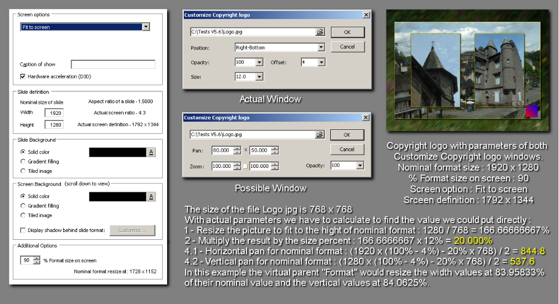
5 – Process to converted all modes to Fit to slide :

5.1 This explanation has the following purposes:
- to give to Igor and the team at WnSoft the details of the formulas that they will need in order to program my algorithm into PTE
- to give to those who currently use Original mode, reassurance that this new method will give the same end result as now
- to give to those who currently use other modes, reassurance that this new method will give the same end result as now
I have made available the following material:
- an Excel spreadsheet file containing the formulas (link here)
- a gif file that is an image of the spreadsheet for those who would like to see the spreadsheet but don't have Excel (link here)
- a zipped PTE project file that demonstrates the result of using v5.52 as we do today and the same result achieved using my algorithm (link here)
- an image made up of some screen-scrapes that shows which fields have been used in the O&A window (see above)

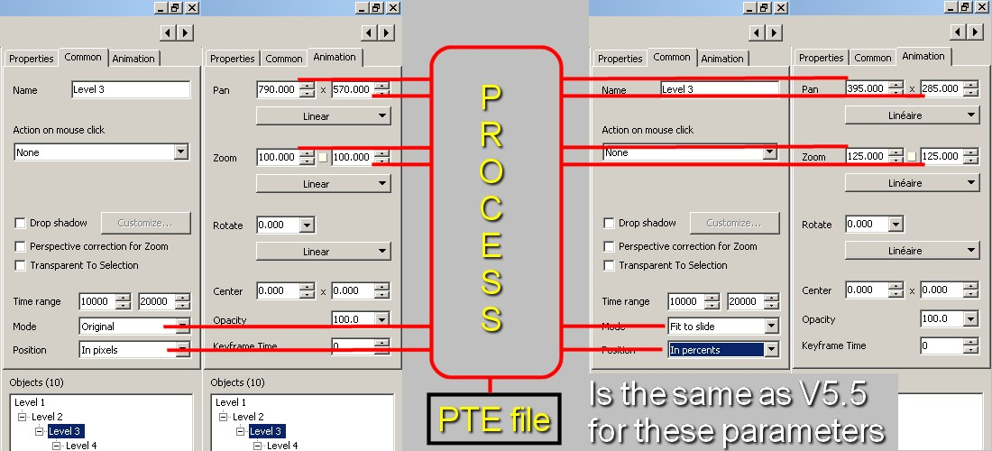
5.2 Process formulas :

This process convert zoom value of different mode in the equivalent one for Fit to slide mode
Horizontal and vertical Zoom to use by V5.6 algorithm :

IF Current object mode is "Original":
1 (one) divide by Min value between :
Parent object width / Current object width and
Parent object height / Current object height
ELSE
IF Current object mode is "Cover":
Max value between :
Parent object width / Current object width and
Parent object height / Current object height
Divide per :
Min value between :
Parent object width / Current object width and
Parent object height / Current object height
ELSE value is 1 (one)

5.2.1 Horizontal Zoom value to be used by V5.6 algorithm :
The result is multiply by : Current object zoom width

5.2.2 Vertical Zoom value to be used by V5.6 algorithm :
The result is multiply by : Current object zoom height

Horizontal and vertical Pan to use by V5.6 algorithm :

5.2.3 Horizontal Pan in percent to use by V5.6 algorithm
IF Current object position is "Pixels";
Current object horizontal pan / Parent object width x 200;
ELSE
Current object horizontal pan)

5.2.4 Vertical Pan in percent to use by V5.6 algorithm
IF Current object position is "Pixels"
Current object vertical pan /Parent object height x 200;
ELSE
Current object vertical pan

With this process, PTE file structure has no change for these parameters, possibility inside the PTE file to keep Pan values in Pixels or Percents, it’s very important for those who use an external tool to create or modify PTE files and also keep the 3 modes :

PosMode in PTE file : Absolute or Percent

FitMode in PTE file : PlaceInto or None or Cover
5.3 Test of the process :
The PTE project contains pairs of images (#2 and #4, #6 and #8, #10 and #12). Slides #2, #6 and #10 are the ones set up using v5.52 features as we do today. Slides #4, #8 and #12 are the ones set up using my algorithm. This was achieved by entering into the spreadsheet the appropriate values (the same values that we would have entered via PTE if it had the algorithm already built in). I then took the calculated results and keyed those numbers into those fields which are available today in v5.52.
Yes, it is only a simulation of the algorithm but it is, I believe, a very accurate simulation.
Slide #2 demonstrates the result for objects that use "Original mode" as many people use with v5.52 today. Slide #6 demonstrates the result on objects of all three of the modes: "Fit to Slide", "Original" and "Cover slide". Slide #10 demonstrates the result on a rotated object (one object from each of the three modes).
The real test comes from slide #13 onwards. Here I show the pairs of slides, one after the other. The only way you should know when the slide has changed is to watch the number at the top of the screen.
In order not to confuse you with too much information, my examples all have the Level1 object as "Fit to Slide". I have two other spreadsheets that handle the situation when Level1 is "Original" and when Level1 is "Cover slide". I can make these available to anyone who wishes to study them. And I will obviously make them available to Igor and his team.
Using this algorithm and with the virtual object Format (VOB) as parent as explained in #1 Structure, there will be no need for anyone to change anything – so all users could work as before. And there will be only one algorithm to code now and to test in future - which should make everyone at WnSoft happy.
Also, we no longer need the "Size/Position…" window!
6 - About OA Windows :
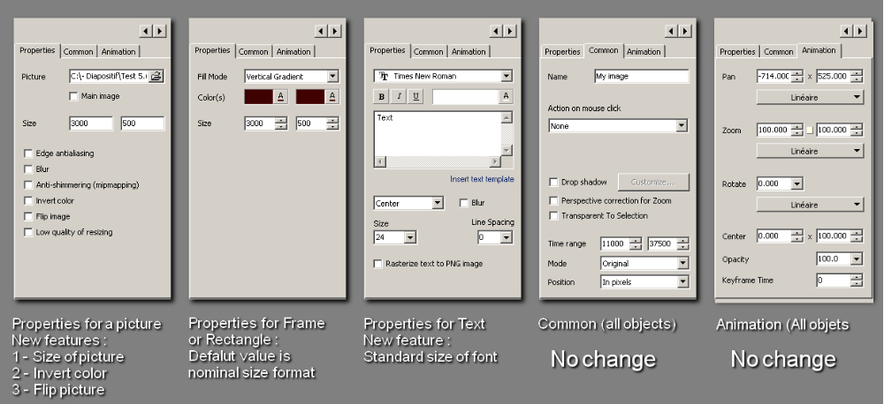
6.1 - For properties :
6.1.1 - When it's a picture, some new features would be interesting :
First : give the size of the selected picture in pixels, that help to work, not obliged to see it with Explorer or other.
Secondly : invert colour of a picture. This feature as absolutely no sense in a slideshow but is often useful when making a slideshow : It will possible to put at the right position an object above a main picture, I made a long time ago a tutorial about that, it simplest to see it to understand what I mean, it's here
Thirdly : Flip the picture (horizontal), like in a mirror, it would sometimes be useful when simulate the rotation of a picture. I don't think it's useful to have a vertical flip, to do it, it's enough to use the horizontal flip and use a 180° rotation.
6.1.2 - When it's a Frame or a rectangle, only one feature possible :
Put as default value those of the current nominal format in order to haven’t too much little percent for the zoom of its children, it’s better for precision.
6.1.3 - When it's a text, only a change which have been ask on Wnsoft forum :
Give the size of font as others programs do, for a default zoom at 100%. It' would be possible now because PTE would know the nominal size of format, of course like in Photoshop, a size for instance of 24 seems smaller on a 1280 x 960 picture (or format for PTE) than on a 800 x 600 picture (always format for PTE), I think it would not necessary to keep Quality option, it would always be possible to put a bigger size, twice for instance, and use a zoom of 50%.
6.2 - For common :
No change, like in V5.5

6.3 - For animation :
No change, like in V5.5
7 - Why it would be simplest and better for users
7.1 - First, with the new screens options :

7.1.1 - We could have the possibility to reduce all the slides and not only the main image, which is a problem today to use this function (safe-zone for instance).

7.1.2 - When format would be reduce, there won't be possibility to see object around when pan zoom or rotation

7.1.3 - It would be possible to do slideshow in original mode but which could be see correctly if the screen definition isn't enough (was a problem for Barry Beckham for instance)

7.1.4 - PTE could be used to drive several video-projectors as it was possible with V4 and V5

7.1.5 - It would be possible to put a screen background picture (outside of the format) as it was possible in V4 when using Copyright logo as screen background and objects for pictures

7.1.6 - The option for shadow wouldn't be on all objects as today, which isn't easy to use, but around the format, which would be easiest to use.
7.2 - With the method of virtual parent Format
7.2.1 - As PTE know for which nominal size it's original mode, it can calculate exactly which is the good resize for width and the good resize for height when the ratio on another screen definition isn't the same as for nominal size. So that, nominal size picture will be always exactly the same size as Format, with even value : picture will never crop as to day it's possible (a very little) or don't be a little smaller than format on screen with problems of lines on the borders (enough to be see by everybody).
7.2.2 - The virtual parent Format as the same effect on its children as a normal object, it can have children using the 3 modes like in V5.52
7.2.3 - The picture will not be resize for nominal format if all zooms of objects and parents are at 100% and original mode for all objects and parents.
7.2.4 - As PTE would know the nominal size of the format, it could use the standard size for fonts as does all programs and not a percent, it would enough easy, I think, to do. To day it's impossible.

7.2.5 – Possibility to have first level object with several mode and objects always correctly placed at different screen resolutions (what was a problem for Wnsoft).
7.3 - With the process to convert mode and position

7.3.1 – PTE have always the 3 modes (it’s possible because of Nominal Format)

7.3.2 – Pixels values can be in PTE files which make possible the use of external tools to create or modify a PTE file.

7.3.3 – As this need only one algorithm, Wnsoft will give us sooner new features

8 - For Wnsoft as developers of PTE
8.1 - It would need only one algorithm for relationship parent-children, this algorithm exist.
8.2 - The definition of a Nominal Format authorize to keep the Original mode without needing of a second algorithm
8.3 - PTE would have more possibilities as today.
8.4 - All the part of PTE would have exactly the same rule to be resized, it would be more logical, it's not absolutely true to day, Tiled background picture and Copyright logo are always resize with there height, the others objects, sometimes on there height, sometimes on there width, it depend of the mode option, the shape of the parent and the shape of the object.

8.5 - PTE 5.6 would be simpler to use and to explain to new users.

8.6 - Some default will be corrected, that will make PTE better and help it to stay the first program in its category.

